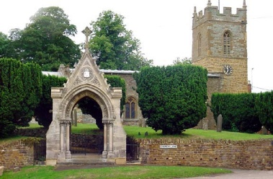
COLD ASHBY
ANNUAL PARISH ASSEMBLY
Wednesday 9th May 2018

Minutes of the annual Cold Ashby Parish Assembly on Wednesday 9th May at 7.30 p.m. in the Sports Pavilion, Stanford Road.
Minutes
1. Councillor Rod Bailey, as chairman of the Parish Council, took the chair.
2. Apologies for absence: Alan Chantler. 16 residents of Cold Ashby in attendance.
3. Minutes of the 2017 assembly were approved as a correct record. It was confirmed that no response had been received on the pathways survey.
4. Welcome and introduction – the chairman explained the purpose and statutory nature of the meeting.
5. Chairman’s report – the chairman of the parish council gave a brief report on the work and achievements of the council in 2017-18, highlighting the important work of Capeg (see later item), and referring to grants awarded, work achieved by the council independently (dog waste bins, defibrillator etc, cemetery wall repaired, well water supply restored) and in collaboration (Stanford road steps, dangerous tree removal, village signs cleaned). Other activities were highlighted as proof of a successful year for the council.
6. Cold Ashby Parish Environment Group (Capeg) – Richard Williams, as chairman of Capeg highlighted the results of work so far: a traffic survey with general credibility showing 35,000 vehicles per week through the village and the convening of a ‘summit’ meeting to discuss the impact of highways and other developments on Cold Ashby. The unavoidable delay in arranging this meeting (originally scheduled in February) had halted Capeg’s plans for further action longer than anticipated and some frustration was evident from those who felt action could go ahead before the outcome of the ‘summit’ was known, given the major negative impact of the traffic increase on the village. The ‘summit’ has been arranged for 22nd May.
7. Northampton Communities Foundation – windfarm fund. A list of successful applications so far was presented.
8. Black Horse: one of the new owners gave an interesting account of their philosophy and hopes for the future as they look for village support. They were thanked and given the best wishes of the meeting.
9. Defibrillator: training is the next step.
10 Euro Garages and plans for Junction 1 on A14: concerns about the nature of this development, the intentions of the site managers and the impact on the village. The meeting urged all concerned to monitor compliance with planning conditions carefully.
11. Councillor Vacancy. One vacancy still on the PC
12. Reports from District and County Councillors if present. None present. Councillor Chantler had been re-elected in the district poll on 3rd May.
13. Open Forum – issues were raised (by TT) about the tidiness of the cremation area in the cemetery and the intrusive nature of the boundary hedge. The council to consider as an agenda item in May 2018. Neighbourhood watch needs to re-form with a more area-based approach. The chairman said this was under active consideration.
G Jones
CAPC clerk May 2018

